SECTION 1:

1. XSS form showing name

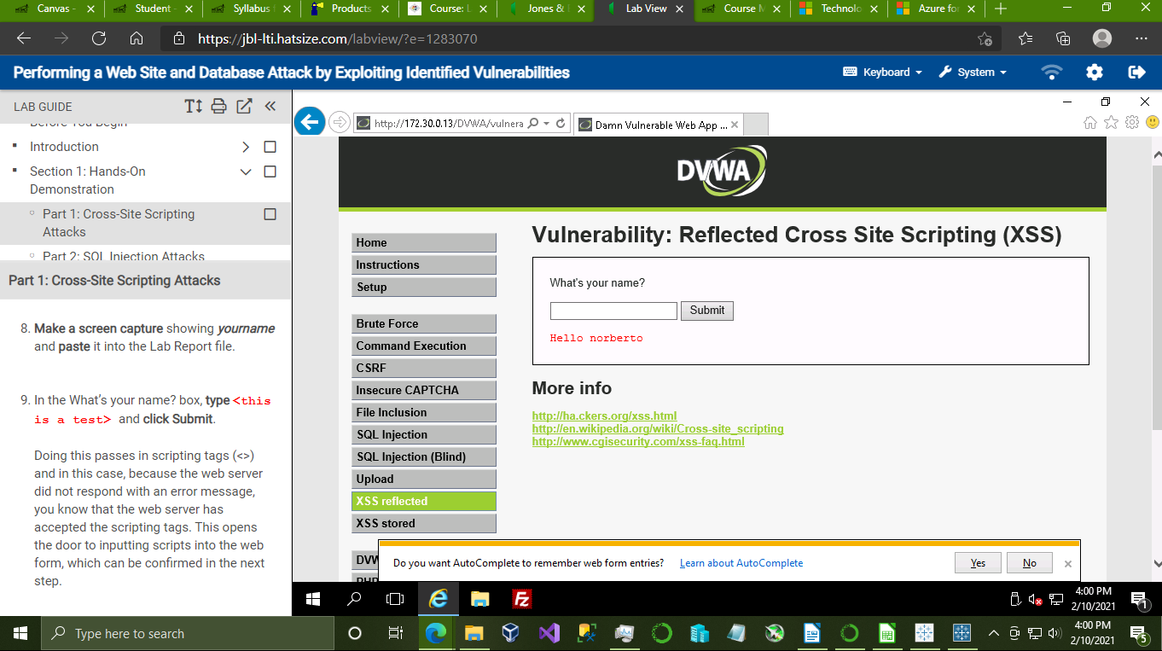

2. XSS form showing the vulnerability pop-up alert

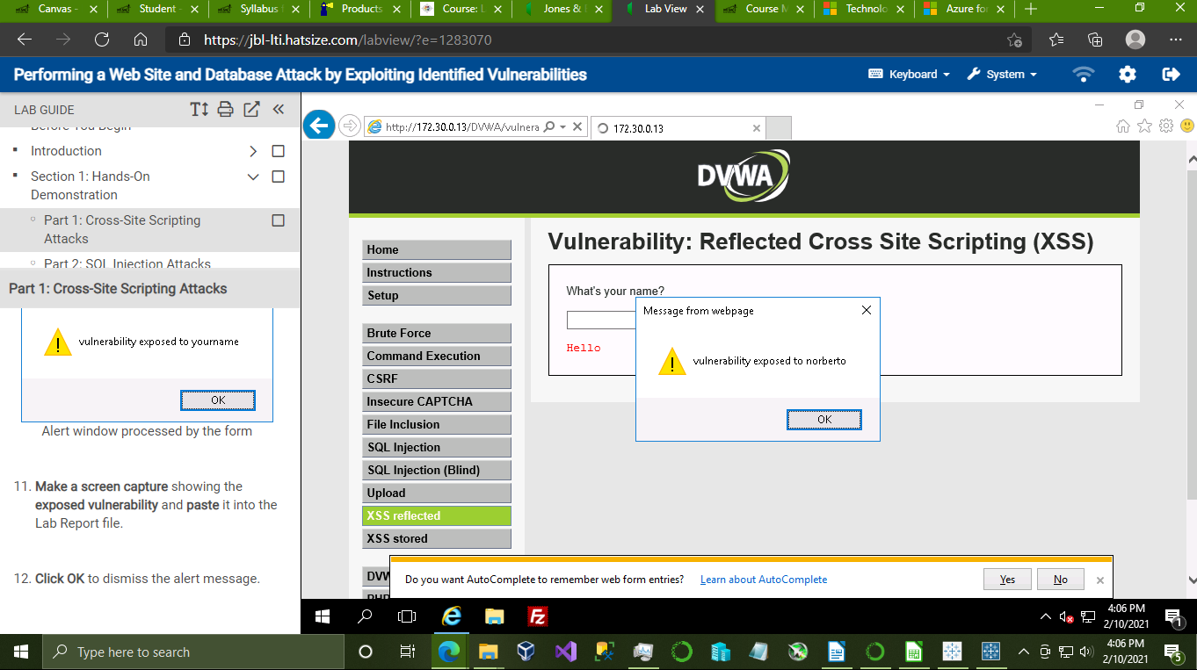

3. SQL Injection user hash information

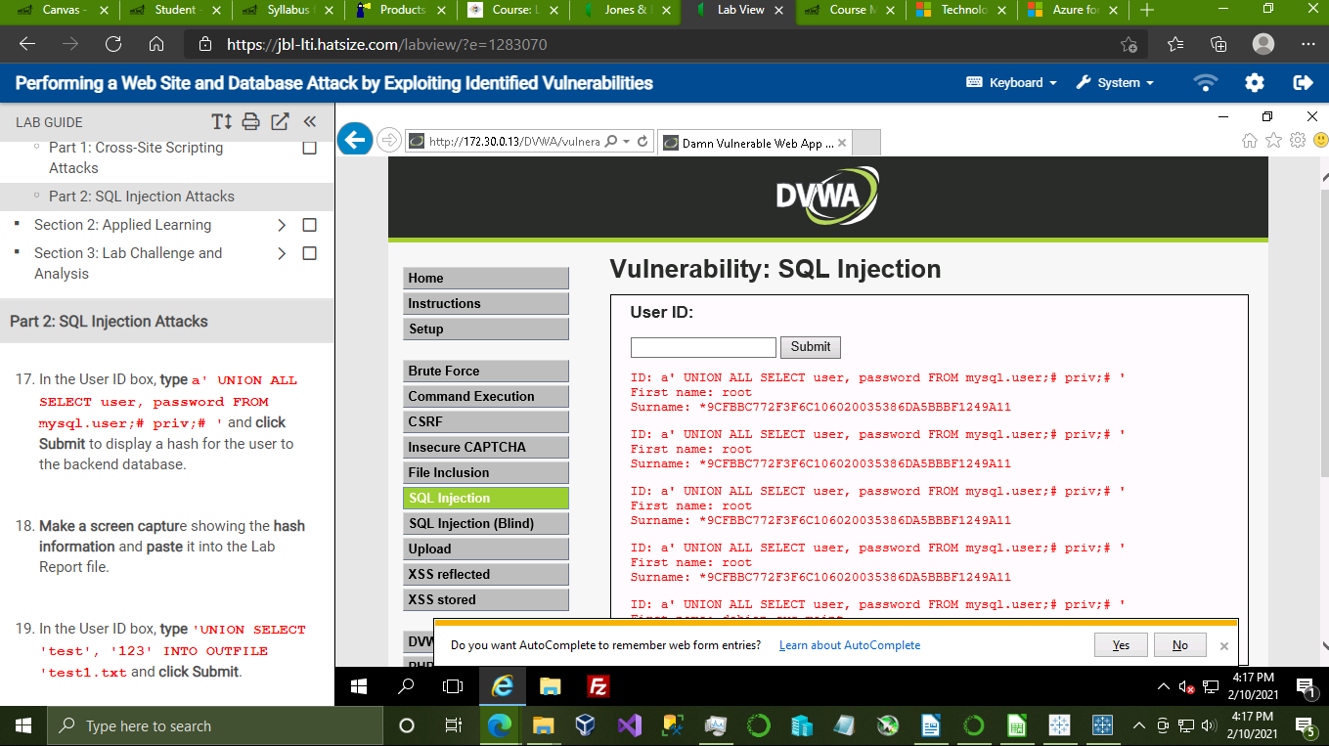

SECTION 2:

1. XSS form showing name

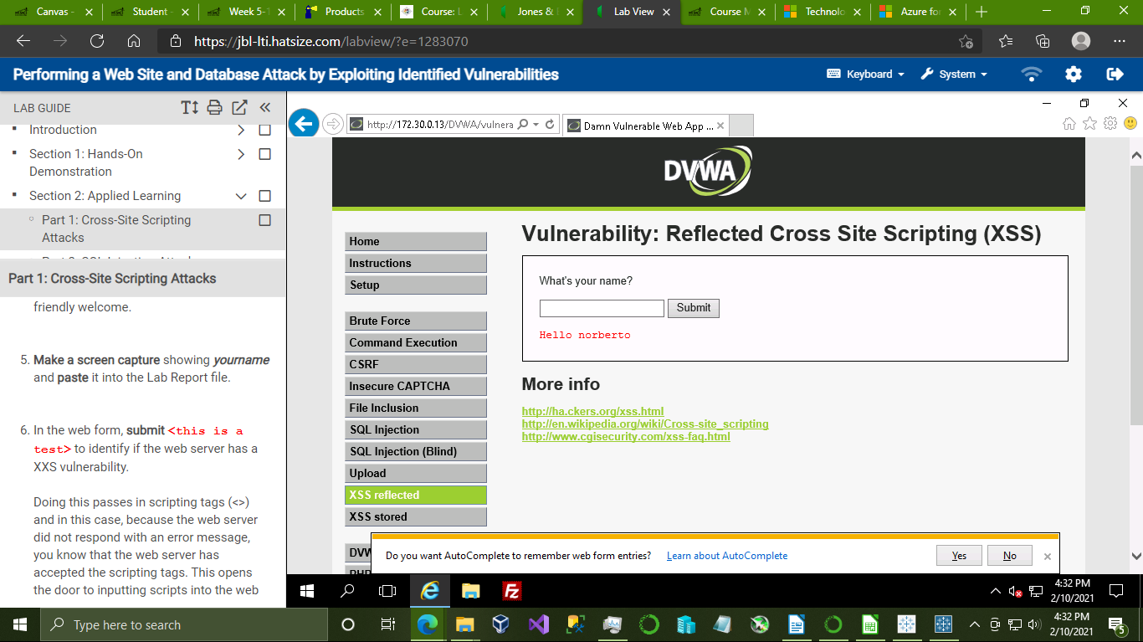

2. XSS form showing the vulnerability pop-up alert

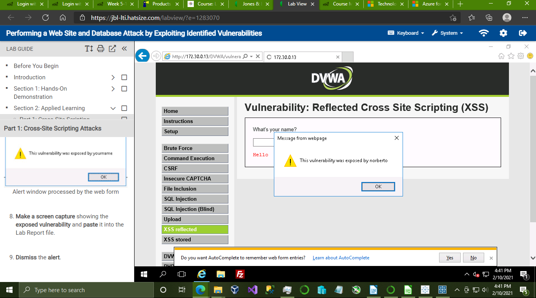

3. submissions that return a response for scripts used to determine the number of columns in a table.

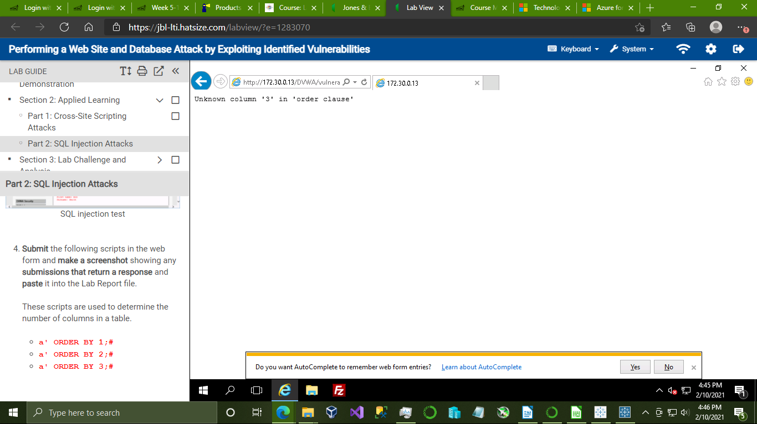

4. submissions that return a response for scripts seeking the correct spelling of a field name

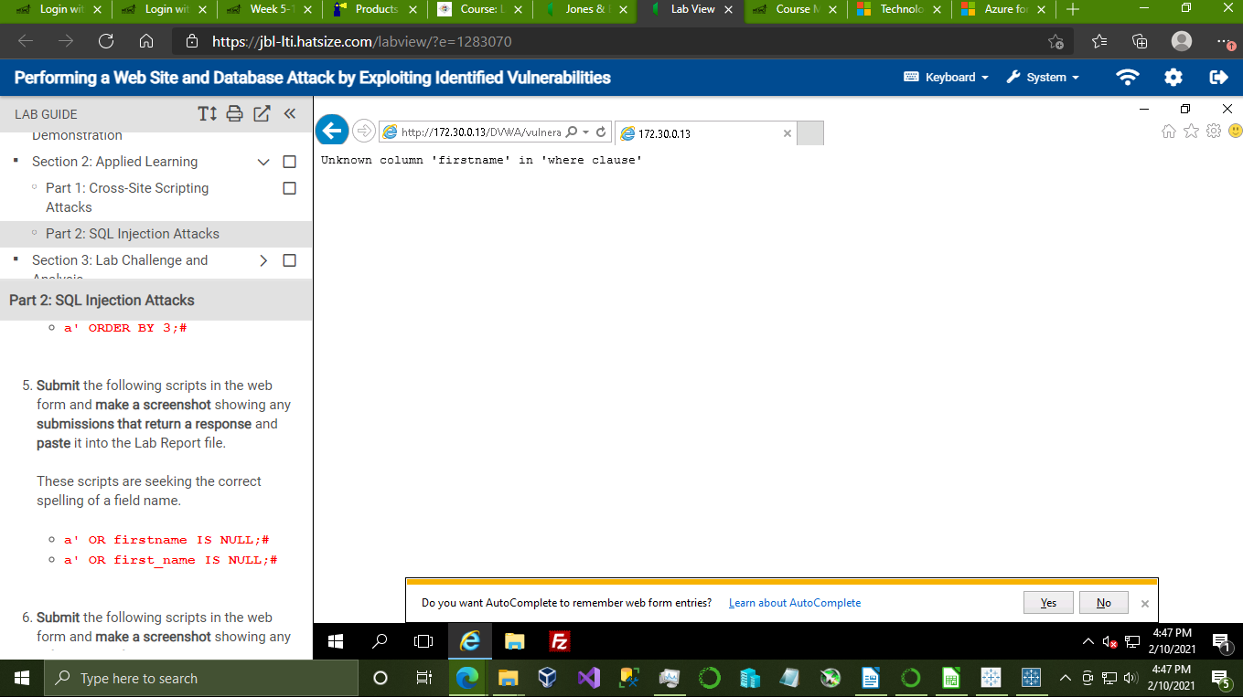

5. submissions that return a response for scripts that search for a possible hit on the databases’s characters

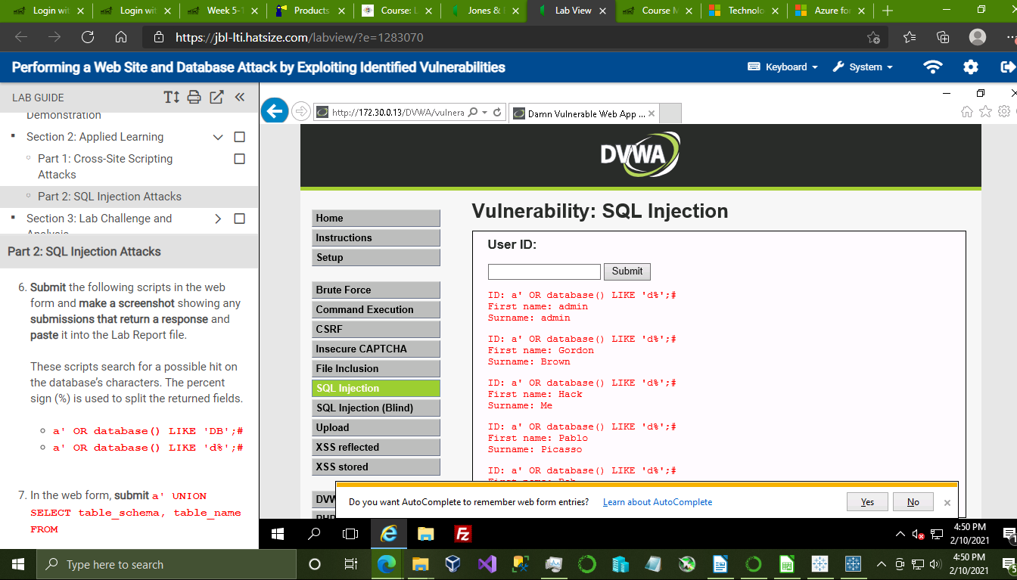

6. SQL Injection user hash information

